

OPERATION ACTIVE RESOLVE INTELLIGENCE SUMMARY D10

# General Information

This intelligence summary covers the last 24 hours (From D10).

# Intelligence

## Air

### Russian and Chinese long-range missiles and modus operandi

Despite the stated maximum range of Russian and Chinese long range missiles are very long, VID have reporting indicating how Russian and Chinese aircraft uses their long range missiles:  
**Anti-ship missiles:**

KH-22 / KH-35: Russian anti-ship missiles (Fired from TU-22 or TU-142)

YJ-83K / YJ-12: Chinese anti-ship missiles (Fired from H-6J)

All anti-ship missiles are deployed from either low-level or high altitude from a distance between 50nm-100nm away from its target.

**Air-to-ground missiles:**

KH-65: Russian air-to-ground missile (Fired from TU-160 or TU-95 Strategic bombers)

KD-20/KD-63: Chinese air-to ground missiles (Fired from H-6J)

All air-ground missiles are launched from their target at a distance at 100nm away from the target. The launch sequence of missiles from the aircrafts will happen at 100nm to ensure correct guiding for the missiles.

**ASSESSMENT:**

It is HIGHLY LIKELY that Russian and Chinese missiles will be fired from these distances.

## Sea

### Russia conducted successful engagements with XXX Anti-ship missile

At 0611G (1811Z D9.1) Russia conducted a successful test launch three KH-22 Anti-ship missiles. The target vessels was stationed just outside the territorial waters of Cyprus (Estimated location: N34 47.000 E034 11.500)

**COMMENT:** The live fire exercise is conducted as part of the Russian-Chinese activity taking place in the EMED.

**ASSESSMENT:** LIKELY intended as show of force. POSSIBLY preparations for further attacks

### Russia and China LIKELY conducted successful live fire exercise

At 1725G-1745G (1925Z-1945Z D9.2) Russia and China conducted a live fire exercise IAW [OPAR VID INTREP Russian And Chinese Live Fire Exercise outside Lebanon](https://raw.githubusercontent.com/132nd-vWing/OPAR-Brief/master/INTELLIGENCE/VID/OPAR%20VID%20INTREP%20Live%20Fire%20Exercise.pdf).

Credible VID reporting indicates that the exercise was LIKELY considered a success of the integration and coordination between Russian and Chinese assets operating together.

## Ground

### Syrian government claims Allied forces conduct bombing of civilians

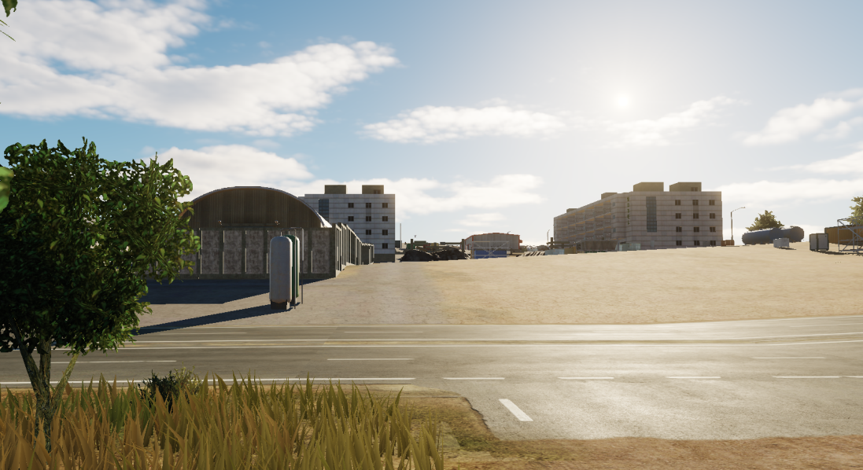

A Civilian hotel (N34 50.650 E035 55.600) along the coast was bombed during D10 by allied forces.

### Patriot battery at Cyprus engaged during coordinated attack

Preliminary analyses and interview with survivors indicate that the Patriot Battery at Cyprus were engaged by multiple missiles from two directions. Between 0705G and 0710G (1905Z-1910Z D9.1) several missiles from different directions was destroying the defenses.

**ASSESSMENT:**

LIKELY that Russian used multiple activities to distract friendly forces.

### MLRS factories increasing output

VID have now credible reporting that indicate that since the start of the war, MLRS rocket production have doubled in the following factories:

* SYTGT010 Homs ammunition factory
* SYTGT011 Raqqa Ammunition Factory
* SYTGT012 Jirah SW Ammunition Factory

In addition, the Syrian armed forces have doubled the production at SYTGT063 Rocket motor production facility in Damascus.

**ASSESSMENT:**

It is HIGHLY LIKELY that the Syrian armed forces are ensuring a steady supply of MLRS rockets to be used in either defensive or offensive operations by doubling the production.

### Artillery ammunition factories increasing output

VID have reporting that confirms a doubling of Syrian production of artillery ammunition in the following factories:

* SYTGT007 Damascus NE Ammunition Factory
* SYTGT008 Tartus Ammunition Factory
* SYTGT009 Damascus N Ammunition Factory

**ASSESSMENT:**

It is HIGHLY LIKELY that the Syrian armed forces are ensuring a steady supply of artillery munitions to be used in either defensive or offensive operations by doubling the production in the mentioned factories.

# VID Intelligence gaps

* VID_IR_1: What is the Syrian readiness for conducting attacks with WMD?
* VID_IR_2: What is the status and disposition of Syrian SCUD units?
* VID_IR_3: What is the status and disposition of Syrian Naval units?
* VID_IR_4: What is the status of Syrian Air Force
  + DCA missions? (Does the Syrian Air Force fly CAPs?)
  + QRA (reaction times?, from what bases? type of aircrafts?)
* VID_IR_5: What is the status of Syrian Air Force A-G missions?
* VID_IR_6: Is there presence of Russian forces in either Tartus or Bassel Al-Assad airfield?
* VID_IR_7: What is the status of Syrian IADS?
  + Positions of EWR
  + Position of SAM sites
  + Is the entire IADS operational?
* VID_IR_8: Are Russian aircraft moving into bases in Egypt?
  + What type of aircraft?
  + How do Russian aircraft operate out from Egypt?
* VID_IR_9: How will Russia and Syria enforce embargo?
  + What are the sources of the attack against logistics ship?
  + What assets can be used for blockade of allied ships?
* VID IR_10: Where will 5th Corps deploy to?
* VID IR_11: What is status and disposition of Syrian 6th Corps
  + What are the composition of 6th Corps
  + How long until 6th Corps are combat ready
* VID IR_12: What is composition of Chinese SAG?
* VID IR_13: What is composition of Russian SAG?
* VID IR_14: What is the unknown Russian-Chinese activity?[1]

1. [VID INTSUM D6, section 2.4.1](https://github.com/132nd-vWing/OPAR-Brief/raw/master/INTELLIGENCE/VID/OPAR%20VID%20INTSUM%20D6.pdf)